SOFT TIME: Heliotrope III

David WOOD, Soft Time: Heliotrope III (2011), Cannon County Arts Center, Woodbury. Wood (cedar & pine), steel, aluminum, laser discs, 16 solar lights. 32 x 16’ sections, 40’ diameter.

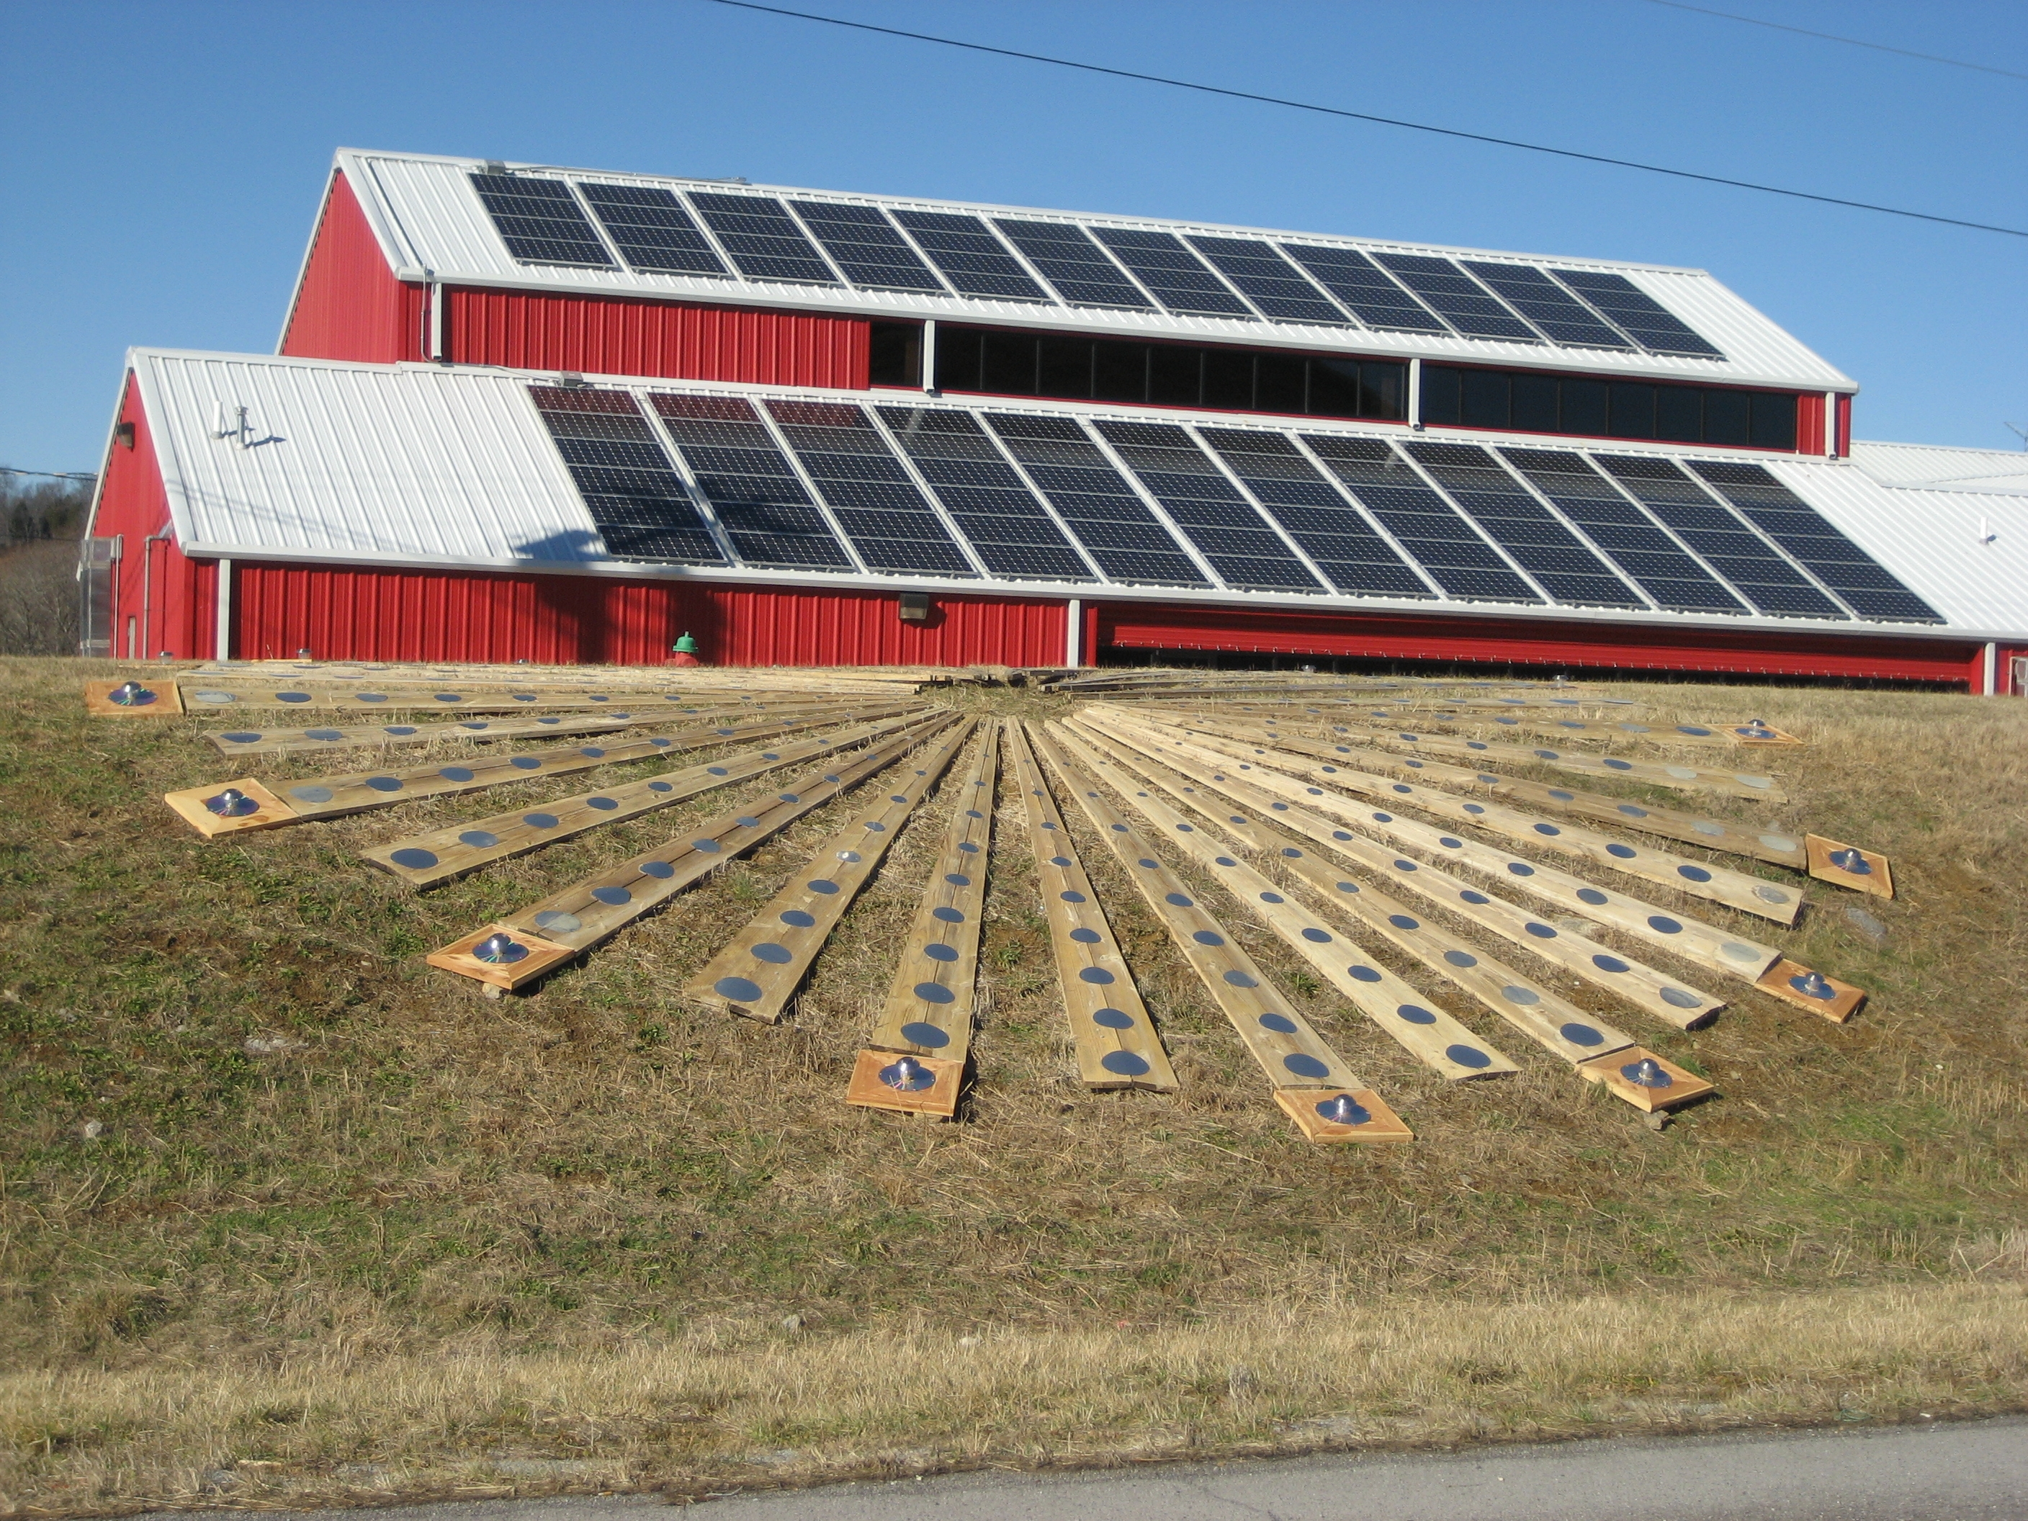

This piece is one of a series that began on the University of Richmond campus in Spring 2010 – first on dry land, where it left a scorched yellow imprint on the grass, then floating in Westhampton Lake. It was later relaunched on Lake Watauga, next to the Parthenon in Centennial Park, Nashville. And for Spring 2011, it has taken on the shape of one of Salvador Dali’s floppy watches, draped over the grassy bank. In this new incarnation, it has acquired a fringe of solar lights, seated on laser discs, centered on islands of cedar.

Soft Time: Heliotrope III is all about ‘connection’. It reminds us of the dependence of all terrestrial life on the sun. It echoes its previous incarnations, and its sister installation, Awakening, on the Vanderbilt campus. Its aluminum discs reflect sunlight and its solar lights store the sun’s energy and come on at night. It bears witness to a new solar dispensation, one in which we live on the daily offerings of the sun rather than plundering finite fossil fuels. By chance its installation coincides with the appearance of a mass of solar panels on the CCAC roof. Change is in the air. We want nature to do our bidding, but sometimes it is best to let it show us what is possible, and adapt. A flat 40’ site by the road was not available here. Folding this piece over the edge of the bank turned a limitation into an opportunity, echoing Dali’s painting The Persistence of Memory, creatively conforming to nature rather than forcing it to do our bidding. Hey – we could have got a bulldozer and flattened the site!

For help in transporting, cleaning, setting-up and in other ways facilitating the installation of this piece, thanks goes to Christina Ott, Joe Prince, MariJo Martinez, Peaches, Rae Ann Schroder, Chip Overstreet, Roy Haney, and the folks at the Cannon County Arts Center - Donald Fann and Evan Hatch.

David Wood is a British artist, Professor of Philosophy, and Professor of Art at Vanderbilt where he teaches continental & environmental philosophy. He runs the Yellow Bird Sculpture Park in Woodbury
See http:// sites.google.com/yellowbirdonline

Email: yourdruid@yahoo.com.

