INTRATERRESTRIALS: LANDING SITES

David Wood

We shall not cease from exploration, and the end of all our exploring will be to arrive where we started and know the place for the first time.
T. S. Eliot, Four Quartets

In 1969 the Apollo 11 expedition to the moon was launched. We now need a new space mission, one that returns us to earth, to rediscover what it might mean to dwell sustainably in this place. We humans are soiling our nest, putting in jeopardy our own capacity to flourish, and condemning to extinction many of the other species with which we share the earth. We need to re-occupy earth.

Von Daniken is not alone in supposing that creatures from outer space once landed here and made otherwise inexplicable contributions to our history. Even today there is serious interest in alien life forms, and the possibility that their flying saucers might occasionally be checking us out. These projections of the alien as beings that might land here from elsewhere hide from us just how unfamiliar we are with our own planet. We need to land on earth to (re) discover it.

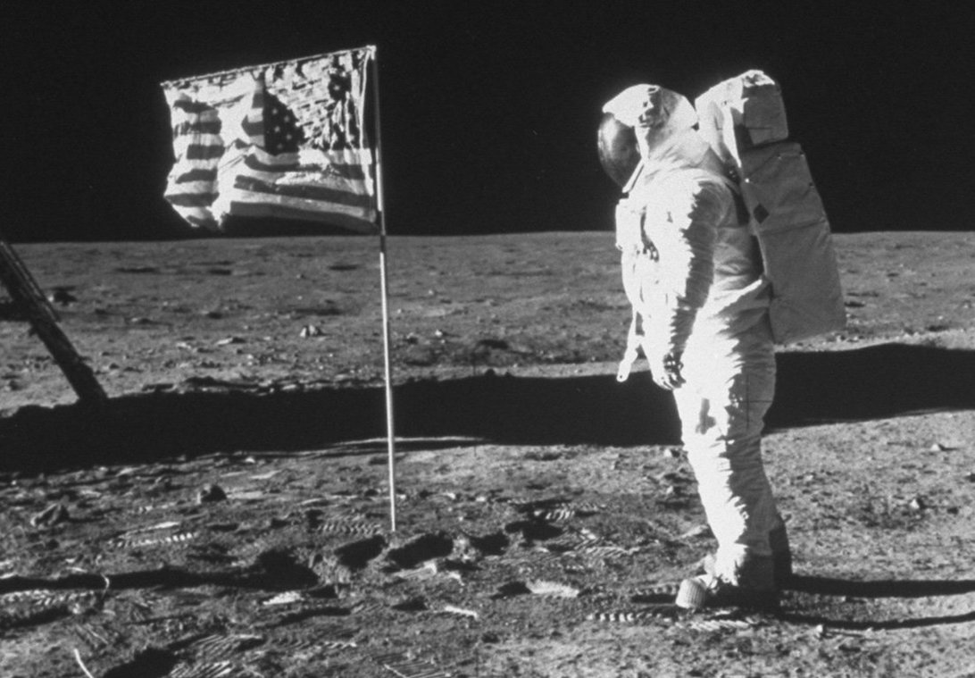

Intraterrestrials: Landing Sites is an ongoing art project dedicated to the Place we call earth. It marks out and documents potential landing sites for imagined earthlings taking a fresh look at our own planet. Some sites have historic significance, others are beautiful, some are scenes of devastation, yet others places of research into sustainability. All have something to teach us. As well as a their own silence from which we can also learn.

We are most at home in the world when familiarity is leavened with a touch of the uncanny, as Heidegger would say. We cannot live without habit, and there is huge resistance to changing our habitual modes of dwelling. Seeing our relation to the earth in a new light may help overcome that resistance. This project contributes to that re-envisioning. Earth itself may be the true Last Frontier.

Part of the challenge of thinking of the earth as (a) place is that it is not just one place among others, but rather the place of places, the Place in which other places find their place. Imagined or temporary sites on the moon or other planets are honorable exceptions. This is perhaps at the heart of Husserl’s insistence that ‘The original ark, earth, does not move’, and its apparent challenge to Copernicus.

I imagined at one point that our dreams of dominance could be interrupted by developing ways in which the earth itself could speak, specific to each site – ways of deploying language that would have a certain unmediated authenticity to them. But what shape could that possibly take? Words soiled with dirt? A happy autochthonous haiku here, a scream there? Some have sought to attribute a Levinasian ‘face’ to the landscape to better honor its joy or plight. Instead I was confronted by the fractal multiplicity of the stories into which each of these sites can be drawn, narratives that both honor and belie their idiosyncratic status. I offer here samples of such narratives. These sites have provoked words and phrases, lines of flight to which they are tied but which they cannot completely accommodate, scattered, as it were, at the threshold. Earthwords. Geo-graphies.

There are seven sites selected here:
1. Po Lam Monastery, Hong Kong
2. Trollers Gill, Appletreewick, Yorkshire, England
3. Civic Center Park (Occupy), Berkeley, CA, USA
4. Institute for Advanced Studies in the Humanities, Edinburgh
5. Lookout Tower, McFadden Peak, Arizona, USA
6. Arbor Low, Derbyshire, England
7. Göreme Open Air Museum, Cappadocia, Turkey

Each of these sites opens onto a struggle between earth and world. Think of the weed pushing up through a crack in an old parking lot. Or the tree strangling an abandoned shed [see photo].

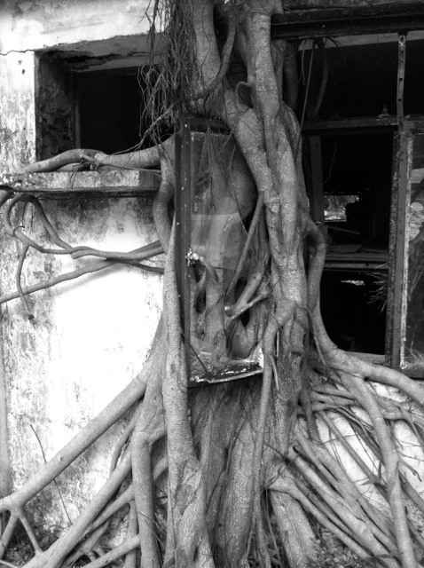

These scenes speak of the earth’s resistance to our dream of domination. Nature bites back. We can be saddened to see our human efforts brought to nought by time and neglect. Or we can delight at the humbling of our hubris. More evenly, we are witness to the ongoing struggle between earth and world, where ‘earth’ designates the pulsating force the Greeks called phusis, the upsurging thrust of nature. While ‘world’ captures our human effort at dwelling, through shaping, speaking, building, making, instituting and so on. Photographs from space of an earth patched with brown, the fields of plastic debris floating in our ocean, dead forests and streams, suggest that this is no ordinary struggle, but something akin to a slow death of a poisoned creature: dying Gaia.

These landing sites do not dramatize the apocalyptic. Rather they offer quieter spaces for contemplating a tension between earth and world whose outcome is as yet undecided. These sites give terrestrial expression to fragments of our existing vocabulary of thinking. But this project can only begin to succeed when its necessary failure is acknowledged.

Our selection of seven sites is drawn from a list twice as long, and the longer list is itself both weakly and strongly arbitrary. Weakly because there are many other interesting sites that could have been chosen with louder or different voices. Strongly arbitrary because in principle there is infinite depth of interest in every square foot of the earth’s surface, if only we would attend to it. Under every rock, a world. Moreover despite the fact that oceans and lakes cover 71% of the earth’s surface, all the landing sites here are on solid ground. This may be sheer terrafirmacentric prejudice! Finally these photographs are performative contradictions. When Heidegger wrote: “These have just been a series of propositions. The point is to follow the movement of showing.” he was pleading for a way of reading. Similarly these images are at best windows on the place we call earth, indexical markers that work only if they successfully both draw us into what they cannot fully (re)present, and renew our vision for what continuously presents itself to our senses at every moment.

The adventure of place represented by trying to present each of their special claims to inclusion in this series has been a revelation. Most of these places were (for me) largely or completely terra incognita before being selected. They found themselves on my list by a dirty mix of intuition and happenstance. Being there opened the senses and fuelled curiosity. What is this HERE? What is happening? How does history permeate place? What words can I use? How should I write? How do images work? Many of these questions address the very idea of place, as well as the specific places being focused on. When we ask “What is happening?” our attention is drawn not to the ‘furniture’ of the place, or the disposition of things, but to place as a site for events and processes. And we are not proposing time-travel when we imagine that place might be constituted by its past(s), as well as its prospects. Is that not our assumption in thinking about the earth as a whole? For it is the fact that climate change makes its future uncertain, and the human future precarious, that prompts the whole Intraterrestrials project.

I began with a certain missionary zeal. I would celebrate our taken-for-granted planet and share my special appreciation for its glory with the sleepwalkers around me. But this hubris quickly got its comeuppance. I came to realize I knew almost nothing about the places I was so naively marking. I had nothing to share but some fancifully idiosyncratic site selections with people who had plenty better places of their own to draw on. Surely one needs to be a purveyor of the extraordinary to be at all interesting. I thought I was practicing ‘art’. But what has any of this to do with art?
There are many books devoted to the wonders of the world, and every tourist destination has its look-out locations, must-see sights, and hot spots of various sorts. The Sierra Club is famous for its stunning photographs of the majestic, the panoramic, the unbelievably cute. As Lydia Millet put it in an essay on ecoporn: “We see the Grand Canyon, cliffs lit orange, with snow in the foreground; we see a fuchsia fog unrolling endlessly over the Northern Cascades under a golden sky; we see an emerald-green pool surrounded by red rock in Havasu Canyon.” But, she continues: “This is picture-book nature, scenic and sublime, praiseworthy but not battle-worthy. Tarted up into perfectly circumscribed simulations of the wild, these props of mainstream environmentalism serve as surrogates for real engagement with wilderness.”
In his classic eco-text A Sand County Almanac, Aldo Leopold extols the virtues of the humble bog or marsh, and the exuberant variety of plant-life enabled by the struggle for survival in poor soil, compared to the Disneyfication of Nature that our eyes often hunker after.
Our eyes are not villains. But the deeper point is that focusing on beauty of this sort tempts us into a distorted understanding of the natural world, and warps our judgment about conservation priorities. Polar bears on isolated ice islands are canaries in the mine quite as much as wooly creatures in need of rescue. We must attend to the mine, in this case melting Arctic ice, and what it portends.
What then of these IntraTerrestrial landing sites? And how to present them? I chose places that are each in their own way interesting. But they are not any sort of top ten. I came to realize I wanted to balance a certain minimal attractiveness of the site with a sense of their substitutability – that one could in principle choose any site and work the same magic. And that this very possibility was intimately bound up with the whole idea of rediscovering the earth. What we cannot help taking for granted at some level, is in fact infinitely rich in ways we are deeply connected to, as terrestrially evolved creatures. Marking a site with a star of surveyors tape is a bit like Heidegger writing the word Being and crossing it out on the printed page. Here is a scene, a spot, a landscape. Come visit. But you cannot actually see what I’m pointing at.

I asked myself how to make each specific site speak for itself, how to cultivate or solicit an autochthonous voice. I imagined accompanying these images with poems made of special words and phrases that would still have the mud of the place clinging to their soles like hiking boots at the end of the day. I do not know any longer whether this makes sense. It seems a tad precious. But the idea of the fractal multiplicity of the being of any place, and by extension the earth, led me to think of narrative, and the idea that each of these places sustains and can nourish a vast range of stories, riffs, and articulated connectedness. So as a substitute for a string of glorious haikus, I have assembled ingredients for longer narratives, which I will ask you to imagine. Is this project art? If we knew what art was, that would be easier to answer. It begins with a conceit – Mission to Earth – which arguably frames it as conceptual art. As for the rest, it is an exercise in seeing afresh, which captures much of what art is about. And then, hopefully, new ways of dwelling.

I. Po Lin, Po Lam Monasteries
Lantau Island, Hong Kong (China)

Burbling visitor voices, sweet incense smoke wafting. Then clouds and quiet distant mist.

“There are no big-shot buddhas in nature.” Ikkyu
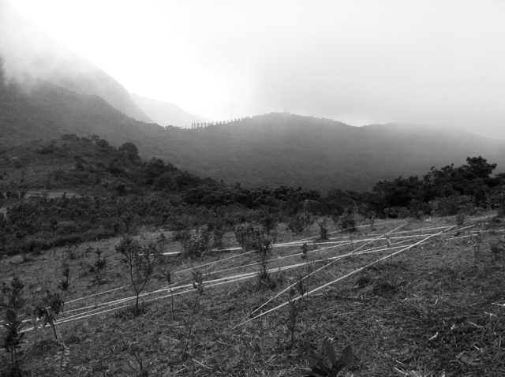

Nietzsche was attacking religion when he wrote “Be true to the earth”. But he was especially against other-worldly religion. The first landing site dramatizes this struggle within religion – in the shape of Buddhism. Around the corner from our site on Lantau Island, Hong Kong, first the Po Lin Buddhist Monastery,
with a 112’ Buddha, the largest in the world. Nearby, connected by walking trails, Po Lam (“jewel of the forest”) a Zen Monastery, deep in the trees: mist and mystery. A choice: tread lightly, meditatively, on the earth or worship a giant Disney Buddha.

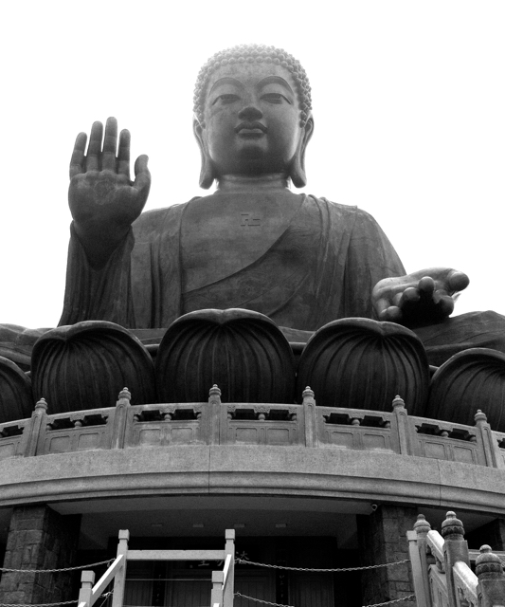

This struggle between interiority and representation by images runs deep. We think we need bold representations to give public and reliable expression to quieter fleeting truth, but in so doing, we risk destroying it. Is that the message of ‘Nature loves to hide’?

Buddhism is not one thing, but its various strands are united against suffering. Much human suffering is the result of illusory cravings that are abated by a simpler life. And suffering extends beyond the human to all living creatures through our disregard for the earth. A recent statement by International Dharma Teachers began: “Today humanity faces an unprecedented crisis of almost unimaginable magnitude. Escalating climate change is altering the global environment so drastically as to force the Earth into a new geological age. Unprecedented levels of suffering for all life on Earth, including human, will result.”

The Buddha lived at a time at which climate change was not an issue, and yet the commitment of Buddhism to kind attentive simplicity has immediate relevance today.

Our site was marked on a forlorn hillside, where there was evidence of reforestation – a few not-quite-dead saplings. In the distance an undecipherable line of grey verticals, like the concrete legs of an unfinished road bridge. Laying out the site with surveyors tape, I realized this was part of Hong Kong, now part of China. What if satellites spotted my activity and construed it as signaling to the West, or preparing an invasion, without permission. Could I be carried off by black helicopters? I had taken temporary possession of these barren hills, treating them simply as part of our earth. But what I was re-marking was already striated by politics, by history, by the designs of others.

The Buddha lived at a time at which climate change was not an issue, and yet the commitment of Buddhism to kind attentive simplicity has immediate relevance today.

The Dharma Teachers’ statement concluded: “When we come together to celebrate our love for the natural world and all of the beings that inhabit it, and when we take a stand to counter the forces of craving, aversion, and delusion, we reclaim our own inner stability and strength and live closer to the truth, closer to the Dharma. Together, we can seek to ensure that our descendants and fellow species inherit a livable planet.”

The giant Buddha, the hidden monastery, and the barren hillside where we made our mark were connected by trails. Walking the trails one could begin to connect their three valences. The seductions of the image even for the spiritual path, quiet withdrawal into a simpler life, and the scrubby nature of a tired hillside. At the edge of the compound housing the giant Buddha, I found an old shed being strangled by a tree. Perhaps a ficus religiosa, beloved of the Buddha. Earth eats world.

II. Trollers Gill
Appletreewick, Yorkshire (England)

Meandering stream, cool air, chirpy birds echoing off the cliff walls.

troller – old English word for walker; gill (gĭl) n. Chiefly British 1. A ravine. 2. A narrow stream. [Middle English gille, from Old Norse gil.] Strange words lodged in my mother tongue.

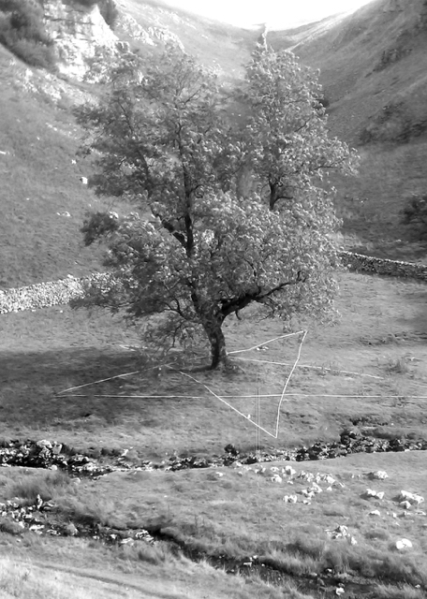

A stone’s throw from the Yorkshire village of Appletreewick, possibly the prettiest village name in the world, I camped with friends in this gorge as a boy, and heard terrifying tales of trolls (with huge saucer shaped eyes) who would hurl rocks down on passers-by. We were advised not to camp too close to the cliff walls.

This place has not gone unnoticed by the poets: “With sheer walls that are in places sixty feet high, it is an uncanny spot: grand and gloomy, weird and wild. All that lives here is in some way bewildered by its surroundings: the wildflowers that bloom among carrion, the wizened trees that crawl out from clefts in the limestone rock, the solitary rook that caws menaces from a slit of sky above. The landmarks too are weighed heavy with enchantment. Prehistoric cup-marked rocks lie scattered about the gill’s depths. Caves and derelict mineshafts discomfit the surrounding hills — black portals into endless night. Lurking among them is the Hell Hole, a natural fissure of an unfathomable nadir that has claimed the life of more than one waylaid adventurer.”

Trollers Gill geologically is a collapsed limestone cavern an “isolated ravine . . . unusually eerie and strangely quiet, not a place to be visited alone”. It is hard to imagine it once being underground, having a giant roof. It’s probably a mile long, with the remains of an ancient dam half way down, where once men had flooded the valley. For most of the year the stream-bed is dry, the water flowing underground.

“Between it all there washes a burn, but even this gibbering companion is intent on trickery. In places its waters drop from sight into subterranean caves, leaving one’s footsteps to beat the scree amid a sudden silence — a game of hide-and-seek that is concluded downstream, where the gushing sprite returns, leaping from its warren with mockery in its murmur. In spate I’ve heard tell that this same stream rips the narrow channel, roaring about the gorge like a lion trapped in an echo-chamber.”

The Gill is also the location of an old lead and later fluorspar mine, last worked in the 1960s. This once underground cavern had its own underground.

“The gill is liminal space, where life and death mingle, and where the imagined world bleeds freely into that of the real. To tread the moonlit paths here is a transgressive act, a journey from the known into the unknown world. Let us wander a while in the unknown, with a spell draped around us like a cloak.”

Childhood memories were vividly in my mind when I returned a few years ago. I was haunted by the trolls. This place seemed to be permeated by the specter of their saucer eyes. At the top end there is a narrow pass through the rocks. I climbed up to what looked like caves, and peered into the darkness. A pair of saucer shaped eyes looked back. And after a few minutes, two more pairs, further back. I had stumbled upon a troll’s nest. I climbed down.

This landing site folds together geological and personal history as layers of place. And now myth and demythologization. I had discovered the basis of the troll story: owls have saucer shaped eyes. Moreover they themselves are bearers of myth, the myth of enlightenment, the evaporation of fairytales. Think Owl of Minerva. Legend also has it that the Gill is the home of the mythical monstrous black dog Barghest who can turn one to stone with a look. That I cannot explain.

The earth speaks in and from this place. The sounds that still echo: gurgle, cheep, rumble, clatter, squelch, rustle, sough. Howl.

III. Civic Center Park
Berkeley, California (USA)

Sweeping brooms, murmur of pedestrians, honk, whistle, squeal and other distant traffic and city sounds.

“All power to the imagination” (Wall slogan, May ’86, Paris)
“Be realistic: demand the impossible” (Che Guevara)

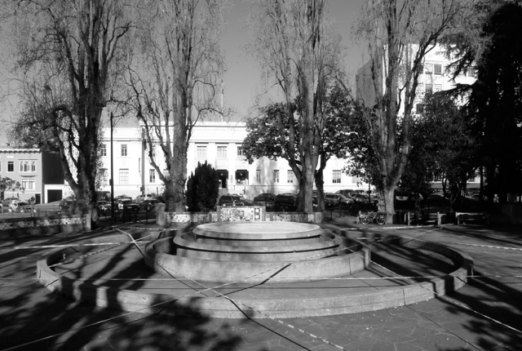

Civic Center Park is not just a place but a place-holder for everything that Berkeley represents. A suburb of San Francisco, on the east shore of the Bay in Alameda County. It is named after the 18th-century Anglo-Irish bishop and philosopher George Berkeley. I once spent a week reading every shred of his writing in the John Rylands library in Manchester while students were on the streets outside celebrating the end of term. Berkeley was a subjective idealist who believed that everything was in the mind. Notwithstanding, in 1728 he set sail for America, convinced that Europe was in spiritual decay and that the New World offered hope for a new golden age. Having secured a charter and promises of funding for a new collegiate community from the British Parliament, he settled in Newport, Rhode Island. However, the funds never materialized, and he and his wife returned to Britain three years later. So much, one might think, for everything being in the mind. It is this idealism, in the more colloquial sense, that the city of Berkeley, the epicenter of liberalism in America, has long stood for. This is in no small measure due to the presence of UC Berkeley, one of the most prestigious and progressive universities in the world.

In 1969, in sympathetic resonance with May’68 in Paris, where placards proclaimed ‘L’imagination au pouvoir’ (“All power to the imagination’), Berkeley was the site of People’s Park, where grass- roots activism, free love, a new spirit of democracy, wafted together in the marijuana camps. In many ways, Berkeley (campus and city) became synonymous with freedom (whatever might be meant by this). And with protest against any incursion on freedom. In 2011, this spirit was rekindled in Civic Center Park (and Sproul Plaza), with Occupy, an anti-Wall St protest movement that set up tents, and moved in. It was a metastasis of the earlier occupation of New York City's Zuccotti Park. Eventually, in a tragic stain on Berkeley’s history, Occupy was violently removed by police.

Occupy Wall Street was a movement protesting against social and economic inequality around the world, and was part of the global justice movement. The word occupy, interestingly, means both ‘reside’ and ‘invade or take over by force’. As a political tactic it developed on campuses in Europe and the US in the 60s when students would walk into administrative offices, make democratic demands, and stay there until removed. ‘Administration’ represented unaccountable top-down power. Occupy in 2011/2012 went beyond the campus, targeting banks and multi-corporations, especially in the light of the US financial crisis (2008) when corrupt financial practices went largely unpunished. This site marks the ongoing battle for social and economic justice, and the very word occupy raises all the right questions about the adequacy of our earthly dwelling. Do we reside on this planet? Or have we invaded it? What would it be to recoccupy it in a different way? What would be at stake?
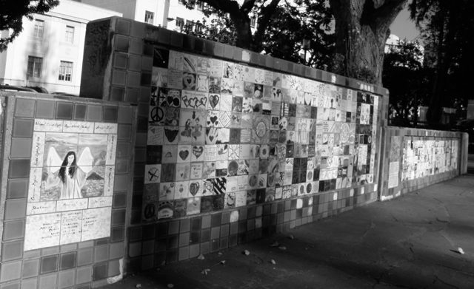

In laying out our surveyor’s tape we met two forms of protest ourselves. The first from lunchtime skateboarders whose concrete playground we were disrupting, and the second from municipal workers, puzzled about what we were doing, whether we had permission. In each case they were assured this was very temporary and business-as-usual would soon be restored. We would have our photographic moment, snatch our prize, and run. Our occupation would happen later, when we wrote, reflected, published, layering on, by bringing out, another layer of memory.

Places are laced with their memories. Landing sites need their pasts excavating, quite as much as their underground cities. The invisible is perfectly real, and takes many forms.

The ‘Wall St’ against which Occupy protested got Its name from a defensive wall built by Dutch settlers on Manhattan Island in the 17th century, fearful that conflict with the English in Europe might spill over into the Colonies.

At Civic Center Park there is a quite different wall, covered in posters, art, graffiti, celebrations of creativity and popular culture. Street Wall perhaps! That there is here a designated place for such effervescence of the human spirit is a compromise. But maybe a lesson. The celebration of difference is protected not impeded by minimal constraint. More generally, a public square is a repository of values, hopes, and possibilities in a world in which these are both dramatically expanding and in other ways threatened.

IV. IASH (Institute for Advanced Studies in the Humanities) Edinburgh, Scotland

Gravel path crunching, gentle tweeting of birds, kitchen clinking offstage, peaceful courtyard

“The life of man is of no greater importance to the universe than that of an oyster.” David Hume

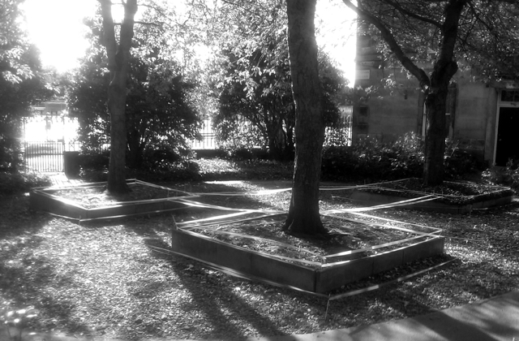

There are places whose location and setting deserves deep exploration, whose reality is geographical, even geological, even if history and often culture will be found trailing behind. This place, however, is distinctive in that it already has its sights on what on earth we humans are up to. It is a site of reflection whose telescope points back home. E-ducation leads us out of ignorance towards knowledge, enlightenment. Higher education takes us beyond transmission of accumulated wisdom to a critical take on what we think we know, and on our frames of reference. A Centre for Advanced Studies must do this in spades.

So, IASH: who do they think they are? “The work of IASH is inspired by the challenge that to understand the world properly we need humanities research. […] Research @ IASH will help us to understand who we are, where we come from, how we live together, and where we might go in the future.” The last time we encountered the future was with the World Heritage Site’s commitment to conservation. But if we are to have a future, conservation will not be enough.

“Interdisciplinarity is particularly important. . . . We offer a space where critical thinking can be free to go beyond the traditional compartmentalisations and cross disciplinary boundaries, in a spirit of innovation and experimentation.” While disciplines are essential for the production of knowledge, the real world is not organized by disciplines. If all the sciences deal with the same matter, that does not mean that we have or could have one integrated science, that some Superphysics could take over history, for example. At the edge, where one disciplinary knowledge meets another, new ideas happen. Some are foolish, but from time to time, there are break-throughs. That this happens routinely is vitally important. Knowledge produced in silos produces technologies that externalize their limitations as ‘costs’ to the earth. Internal combustion engines are brilliant devices but they treat the atmosphere as a passive and infinite sink. Interdisciplinary thinking counteracts that tendency. And interestingly, when it comes to technology or the application of knowledge, this leads directly to cooperative social processes, in which the views of experts can be drawn into wider conversations. Think of city planning. Or the management of watersheds.

“We encourage work that is inventive and exploratory, and especially work that forges links between the humanities and the interpretive or historical social sciences, and between the humanities in this broad sense and the medical, natural and technological sciences.”

Precisely. And this reference to the inventive and exploratory is vital. Arguably such work is not itself ‘science’ but the deep conversation in which science itself is born and continues to bath.

Such a place as IASH occupies space on the planet. But it does so as a site of reflection upon that same planet, and our sojourn on it. It’s courtyard nicely captures what Heidegger would call the (ongoing) struggle between earth and world. Three square plots, each framed in wood, rotationally off-centred in a brick-paved courtyard, each covered in ivy and planted with a cherry tree, with interspersed seats for peripatetic conversations among the Fellows. Drawing these together, coloured surveyor’s tape, following the outline, stitched together with connecting ribbon alleys. Cherry trees, something of a symbol of upsurging physis with their blossoming and fruiting, yet organized in a geometrical grid. Geometrees. All set within high walls and gates. Light only squeezes in at odd times of day, from awkward angles.

IASH itself inherits the legacy of the eighteenth century Scottish Enlightenment, and the likes of David Hume, James Hutton and Adam Smith. They were each regarded as heretics challenging the teachings of the established church. If we no longer believe that the earth was created 6000 years ago it is largely because of Hutton’s insistence that we replace theology with geology. The planet is exceedingly old, constantly changing, and the centre molten rock. Knowledge and observation will set us free. Hume similarly taught us to trust our senses, to be skeptical of dogma and superstition, and form our own opinions. While Smith taught that sympathy for our fellow men makes our well-being dependent on their happiness. And that the pursuit of economic self-interest will, by an invisible hand, promote the general good. These were revolutionary ideas. It is chastening to realize that the dogmas of the church at that time have been replaced by the unsustainable ideology of the free market, which can seem as impossible to challenge as the church was then. Paradoxically, Smith, and perhaps the whole Enlightenment ethos, had some hand in that new faith! Could the discovery of the limits of enlightenment be part of a new enlightenment? Would not IASH, in dynamic Edinburgh, be just the place for this happen?

V. Fire Lookout Tower
McFadden Peak, Arizona (USA)

Resinous scent of pine, a sky-swept silence, far away birds. Radon seeping from the earth.

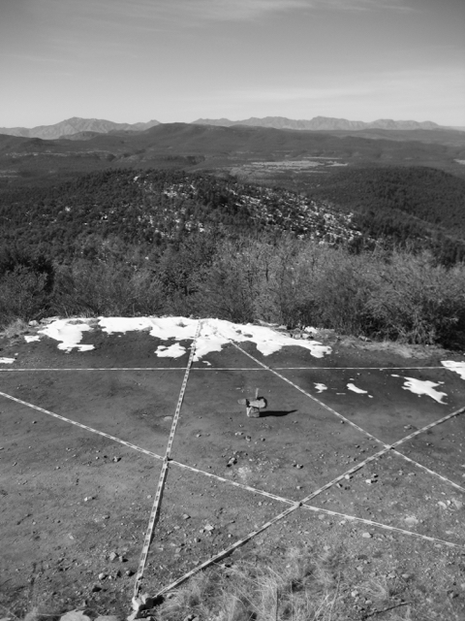

McFadden Peak, the site of one of two fire lookouts in the Sierra Ancha, in the Toto National Forest, Arizona, offers continuous views of the surrounding areas. It seems so unprepossessing: just another fire-tower.

This peak was named after William McFadden, who had fought in the Pleasant Valley War (1882-1892), and later settled near here at Circle Ranch to get away from one of the most lethal feuds in American history, fought between two families, the ranchers Grahams and Tewksburys, and which killed most of their adult men. It led to the postponement of Arizona’s statehood by ten years!

The tower is a concrete structure capped by a flattop metal viewing room with catwalk. From the lookout tower, at an elevation of 7135', the forest of pinyon pine, alligator juniper, mountain mahogany, gambel oaks and ponderosa pines stretches to the horizon in every direction. Even the names of the tree species wake the tongue to song. There are spectacular 360º views of the White Mountains, Superstition Mountain, the Mogollon Rim. The peak itself is made of a pale colored Troy Quartzite rock.

Heraclitus of Ephesus was a lonely man. His fame rests on proclaiming that everything deep down was fire. Be that as it may, this fire-tower exists to spot real fires that can destroy whole forests. From its Olympian heights vast distances can be effortlessly surveyed and in the absence of fire there is nothing else to be done. Forest fire presents a classic environmental problem. Even when there are no buildings threatened, it is hard for us not to see the upshot of forest fire as devastation. That there are some pine-cones that need fire to germinate seems like opportunism rather than a thumbs up. So much else dies and is destroyed. We may accept philosophically a dialectic between creation and destruction, and we justly celebrate the green shoots of recovery. But we strive vigorously to contain wildfires, which make an instant mockery of our individual efforts to cut our carbon emissions. Hence the lookout tower.

For a philosopher it is hard not to compare the stance of the great systematic thinkers like Hegel or Plato and their ‘pensėe du survol’, which for a phenomenologist (or indeed an ordinary mortal) can seem so out of touch with what is happening on the ground. And yet this peak is a ground – high ground as we say. When we marvel at the Apollo photographs of the earth from space, and the uncanny displacement effects they induce, we should not forget that humans with access to hills have always had this capacity to look back, look down, on the earth, if only one piece at a time. Not to mention choosing such places to look up at the sky. We know something of a birds-eye view, even if we do not have wings. When one adds to the mix the subterranean cities of Capadoccia, and mining, not to mention swimming and sea-faring, it makes one realize that even before air-travel, we humans have never simply lived ‘on the surface’ of the planet. We have dug, dived, explored hills and holes, like all-in-one animals.

Just below McFadden Peak there are warning signs. If preventing fire, one of Nature’s primal elements, places us squarely in the position of trying at least to manage if not dominate Nature, what lies hidden in the forest raises the bar exponentially. Uranium mines. Abandoned diggings, often improperly sealed.

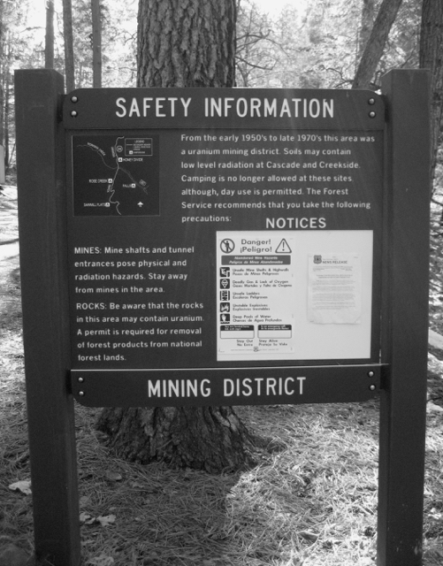

After WWII the US stepped up uranium mining to create stockpiles of nuclear weapons. “Large uranium deposits were found on and near the Navajo Reservation, and mining companies hired many Navajos. Disregarding the health risks of radiation exposure, the private companies and the United States Atomic Energy Commission failed to inform the Navajo workers about the dangers. High rates of illness began to occur.”

Mushroom clouds are a different order of fire. Splitting the atom might be thought to be a natural phenomenon. After all e four-legged creatures did it! And yet a line was crossed. As for racist disregard for the lives of our fellow man (yesterday smallpox blankets, today radiation disease - on the heels of systematic genocide) – perhaps that line was crossed long ago. Bill McKibben long ago announced the end of nature, but we humans do seem to occupy the strangest of liminal spaces – wholly ‘natural’ beings in some sense, while trying to manage and control it, even as at times we destroy it. There are those who have no time for Nature, as if it is nothing if not Pure. But one need not believe in the pristine to acknowledge the destruction of planetary support systems that have made possible the bounty of life before us today. Poisons do not just readjust matter and open up new opportunities, they destroy whole interconnected lifeworlds.

The McFadden Peak look-out tower surveys a scene that sequesters a tragic history. The UN Charter of Human Rights and the Nuclear Nonproliferation Treaty are perhaps the look-out towers that the Navajo (and the citizens of Hiroshima of, and Nagasaki) needed.

VI. Göreme Açık Hava Musezi (Göreme Open Air Museum)
Cappadocia, Central Anatolia, Turkey

Heat and smell of soft tuff stone, cones, pillars, pinnacles, mushrooms, and chimneys, scuffing footfalls of visitors.

“The dream house must possess every virtue. However spacious it must also be a cottage, a dovecote, a nest . . .” Bachelard

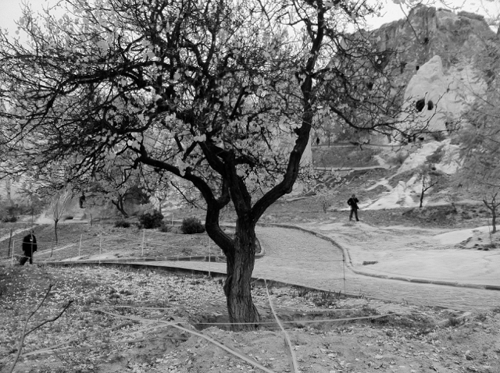

As a landing site for intra-terrestrials, intrepid terranauts, Cappadocia is if anything too special. An earthling would not so much see earth anew through this place as suppose they had landed on a wholly different planet. And yet that is perhaps only the first step towards realizing the stunning diversity of what we call our earth. So much of what falls to our eyes just round the corner is out of this world. Could this truly be too special? Perhaps yes, because it feasts the eyes, like ecoporn. If we had eyes to see, even the most ordinary is spectacularly complex, fractally fascinating.

Conspicuous geology. They are called fairy chimneys. As far as you can see giant pointy people, stone creatures gathered for a concert in the valley. You look out at this scene and think – this place was not made for us, it just came out like this. It’s just what happens when volcanoes shoot out ash that gets consolidated into soft tuff rock, that the elements sculpt away. And yet, these rocky pinnacles are now happily pock-marked everywhere with the entrance holes of human termites. Who would guess they are the local luxury equivalents of penthouse suites for well-off troglodytes. At a constant 18⁰C. With wi-fi.
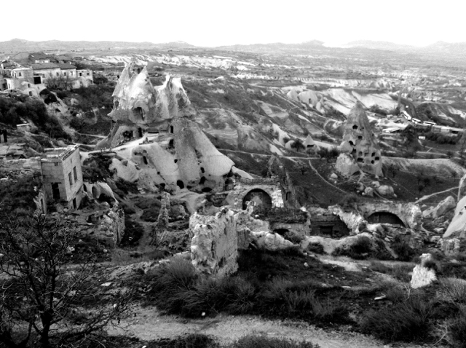

Beyond what one can see with an astonished eye, there are the sedimentations of time, space and history. For the area has been inhabited for over a millennium. This museum is a World Heritage site dating back to the eleventh century when it was settled by Byzantine Christian monks who carved extensive chapels and living quarters, indeed whole cities, burrowed many floors underground in the soft stone, where they would take refuge from invading forces. The chapels are full of ancient frescoes, evidence of a lively, colorful, civilization.

Laying out our surveyor’s tape grid, we were challenged by uniformed guards. We had after all, stepped over the rope barriers, without permission. This was, after all a World Heritage site. My Turkish assistant explained that this was ART, and we were left alone.

The World Heritage Site program “catalogues, names, and conserves sites of outstanding cultural or natural importance to the common heritage of humanity.” Is tis competition for my own IntraTerrestrials project? In Cappadocia we have one chance overlap. Their sites are rigorously selected for importance by committee from many contenders. My sites are selected by me, often by chance, then explored. They are serving the World; I am shining a light on the Earth. They highlight the spectacular. I pick special places as sites for excavation of dimensions found anywhere. In truth, IntraTerrestrials does not and cannot stick to ‘Earth’ (as opposed to World). Perhaps the difference is that WHS celebrates ‘heritage’, a treasure trove of justifications for the human presence on the planet, while IT ponders it.

Cappadocia shouts dwelling, the creative adaptation of homo sapiens to the most unlikely landscape. If once we sought caves for shelter and safety, here we found places to make caves to our own specifications. The Great Chain of Being typically starts with Man, and passes through Animal and Plant before it lands on Rock (often with resident lizard). Rock: hard, permanent, and resistant. We are told to build our foundations upon a rock. Here, however, the rock has yielded gracefully first to the wind and the rain and then to the chisel, not so much that to which we oppose ourselves, or something to be conquered, as to be worked on, worked with. Then lived in. Made into ‘a dovecote, a nest’.

If this place could speak? Cries of Turkish birds and wind:
hışırtı, inilti, düdük, çip, dingin, dokunun, üfürüm, şarkı, mmmm, ok ok, tıklatın, vızıldamak, çatlamak, bam, kükreme, cıvıldamak, uuuuuuuuuu uuuuuuuuuu, hışır hışır hışır, ahhh telaş haşır, huşur, ıslık, fuit, tak tuk tak, tukfıs, fıs, fıs, fıs, pıs pıs pıs pıs.

VII. Arbor Low
Peak District, Derbyshire (England)

Soft breeze, crushed meadow grass, nearby farmyard fragrances

“The name Arbor Low appears to derive from the [Anglo-Saxon] ‘Eorthburg Hlaw’, meaning ‘earthwork mound’.

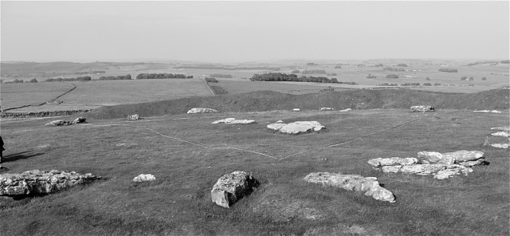

Arbor Low is a Neolithic stone circle dating from 2500BC, set on a limestone plateau, open to the sky, and with panoramic views over the White Peak area of the Peak District, Derbyshire (England).

Human skeletal remains have been found here, along with pottery and other grave goods. It seems to have been a site of pre-Christian religious significance.

“It consists of a massive bank and internal ditch surrounding a central area with stone settings. All the earthworks are substantial and they would have taken a considerable time to build. Perhaps the co-operative acts of construction were as socially important as the monuments themselves.”

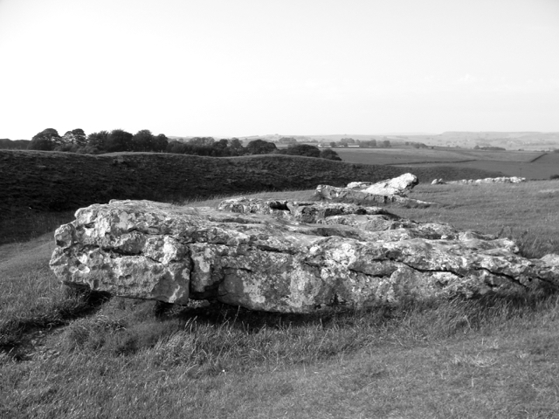

It encloses the ruined and fallen remains of limestone slabs and pieces of a large stone circle. There were originally over 40 stones in the ring, planted upright in shallow holes.

It was a grey day when we visited, with a flat stretched sky. There were a handful of other visitors, sniffing around. One spoke of it being part of a network of ley lines, whether mystical alignments or connecting tracks. No-one could fail to respond to the resonances of a very different way of life, one with its own customs, reverences, and sociality. A monument of another time, another age, still, as it was then, set perfectly and powerfully in the landscape. We should be chastened by the thought that while those people lived and died as we do, their way of life hardly scratched the surface of the earth; rough it may have been, it was sustainable. It is an irony perhaps that the stone these ‘primitive’ people used for their structures ensured their survival, albeit knocked about a bit. More sophisticated wooden structures would be long gone.

They were also in touch with the sky. Here perhaps is the source of spiritual connection. The landscape may well have changed, groomed and cultivated in new ways. But the sky must be little different. It is hard to imagine these people suffering from nature deficit disorder. They might well have echoed Pascal’s “The eternal silence of these infinite spaces frightens me.” Or at least evoked wonder. Moreover from the sky, if the gods are looking, Arbor Low would be magnificently visible. One could not hope for a more inviting landing site.

Marking each of these sites with different colors of surveyors tape, usually in the shape of a star, was a meditative exercise. It was a primitive temporary ironic form of possession, a kind of writing of the earth, a repeated signature. The resulting designs were on a scale that would be visible from space. As well as helping to guide the terranauts on their Apollo Mission to Earth, I imagined I was signaling to the gods, opening the earth to another perspective. Truth is that the other perspective needed is not one of alienated distance but rather of dwelling. Were the gods peeking down they would be laughing or crying. If there is still a place for the gods-eye view, it is one that would knit together these seven sites and the stories spun around them, along with those of innumerable other possible sites, into a sense of the earth as a whole. Whether is not we call it Gaia, the point of any one of these ‘landings’, which are beginning to happen in this text, is to both open us out onto the human and often pre-human history stored up in them, and also to see them as connected to each other in ways not always obvious. We cannot simply look locally and think globally. Thoughtful attention has to play back and forth between the local and the global, not least by the extraordinary resources opened up by the internet. It can be a potent ally in a complex mindfulness. We can of course drown in information overload but we can also learn to swim, to use it to make connections that make the invisible visible.

Heidegger understood art as animating the inevitable struggle between earth and world. He insisted it requires preservers. In the case of IntraTerrestrials: Landing Sites, if it can claim to be art, preservation would consist in picking up the ball and running with it. Every square inch of this place is worth our wondrous attention. Under every rock a world.

See his Chariots of the Gods, Berkley, 1999, where he claims, inter alia, that only extra-terrestrials with special talents can explain the pyramids.
Did a spaceship crash-land at Roswell in 1947? Is the US air force suppressing the truth?
See my Reinhabiting the Earth, New York: Fordham, 2017
See writings by Casey and by Llewelyn.
I allude here to Heidegger. See for example, “The Origin of the Work of Art”, Poetry Language Thought, New York: Harper, 1971
Aldo Leopold, A Sand County Almanac, Oxford: OUP, 1949
See “The Earth as Witness”, One Earth Sangha (web resource)
See Black Dog Traditions of England, Ian Humberstone, David Chatton Barker, et al.
ibid
ibid
Ian Humberstone (see earlier footnote) does this better than anyone.
This and subsequent quotes come from the IASH webpage. http://www.iash.ed.ac.uk/
Wikipedia, Uranium Mining in Arizona.
See for example Steve Vogel, Thinking like a Mall, MIT, 2015
English Heritage website
ibid
Bruno Latour has recently argued for the power of this concept.
An extended version of Intra-Terrestrials: Landing Sites can be found at www.intraterrestrials.org.

